Saltro16 and padplane

The Lund group, Feb 8 2011

The Saltro16 silicon die itself is 8x5.25mm² and contains 16 readout channels which equal 2.625mm² per channel. The defined goals are to organize the electronics components such that their density is compatible with a pad size of 1x6 mm² in the case of the Saltro16 chips and 1x4 mm² in the case of Saltro64.
For the rest of this document, it's assumed that we will mount the Saltro16 chip directly on a special board, as a bare wire-bonded die, commonly referred to as a multi-chip-module or MCM.
It's often also written in the form MCM-L where L means that the carrier is a laminate (printed circuit board), another common type is MCM-D where D means deposited i.e. a silicon carrier.

Since bonded chips are hard to replace and epoxy-protected chips virtually impossible to replace, a MCM approach to modularization should mean that board-controller, voltage-regulator and bus-drivers are separated from the Saltro16 chip board and are mounted on a
mezzanine board.

Another possibility is to use a so-called flip-chip technology which in short means that the die-pads are larger than ordinary chip-pads and that a solder bump is placed on them.
This mounting technique which allows higher density, but it also requires that the chip is designed with special pads for soldering directly on the board.
The final alternative may be a packaged chip with this technology, but this always means lower density although testing, mounting and service will be simpler.
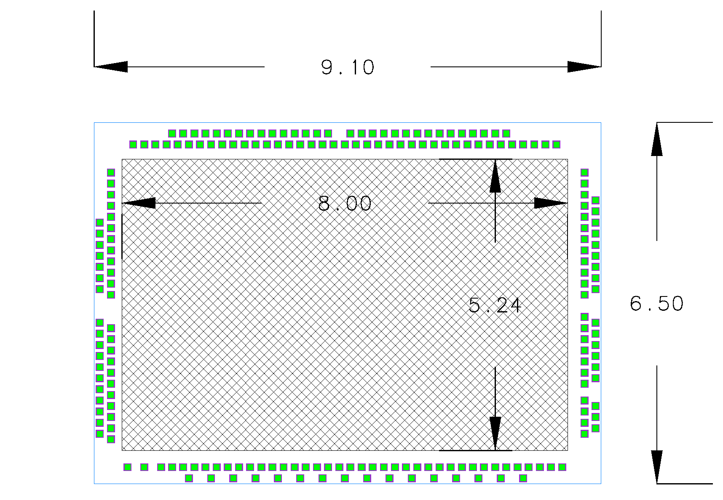
Figure 1. Saltro16 die + bond frame

Any way which is used to physically connect the Saltro16 will lead to an increase of the pad-size/channel, just the frame around the Saltro16 die to allow bonding of the chip increases the area occupied by the chip+interconnect to 9.1x6.5mm² or 3.70mm² per channel.
Note in figure 1 that the bond pads are distributed in 2 'layers' to increase density and ensure that the bond pad pitch doesn't define the required chip area.
The Saltro16 also need some resistors and capacitors in close vicinity and choosing these with the smallest available package (0201 = 0.5x0.25mm²) further increases the necessary area as does the space occupied for input routing. The resulting minimum area for a connected Saltro16 chip is then about 12.2x10.8mm² or 8.235mm² per channel (see figure 2).
Such a chip will still need buffering for clocks and thresholds as well as some kind of chip- or board-controller which further increase the necessary area.
This support-electronics also depend on the modularity of read-out (e.g. 8 Altro chips per buffer and board-controller on current FEC + connectors for such functions) and as we already suggested to mount this on a separate mezzanine board, we currently ignore this whenever we do the calculations of occupied space, although we must keep in mind that we must always have at least a connector to his mezzanine board.

If we start looking at the simplest case of mounting Saltro16 on only one side of a board we find that mounting a Saltro16 directly onto the backside of a pad plane thus imply a pad-pitch of no less than 8.235mm².

Furthermore, mounting the die directly onto the backside of the pad plane requires 100% tested chips and if the chips are epoxy protected (for bond-wire protection) the chips aren't replaceable which means that the complete pad board has to be replaced when too many chips have died.

Figure 2 shows the minimum area needed by the Saltro16 and passive support components. Notice that in this picture there is a connector that carries 16 inputs each to 2 Saltro16 chips and there is 1 chip on each side of the board. For mounting on the back of the pad plane the connector isn't needed, however input routing and vias are still needed which only slightly decreases the necessary board area.
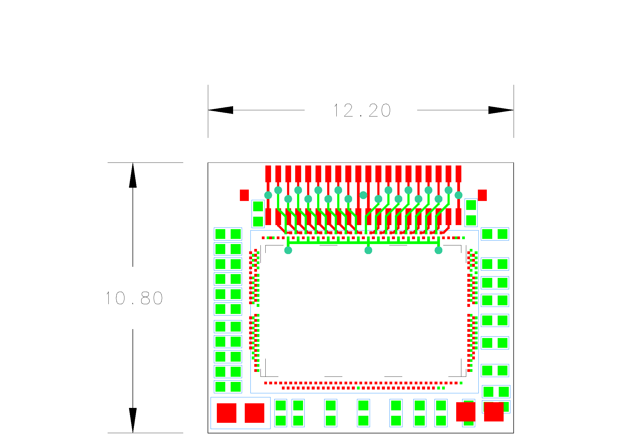
Figure 2. Minimum area occupied by Saltro16 + support components

In the scheme of mounting Saltro16 chips directly on the back of the pad board, great care has to be taken in the orientation and placing of the Saltro chips since the chip input never are allowed to face the digital outputs of another chip.

Saltro16 inputs

During the test beam runs at DESY we have had several different chips with dead channels due to mishaps during data taking which have caused a costly chip-replacement.
The inputs of the Saltro16 are supposed to have a better input protection, but since dying channels are a much more severe problem when the chips are bonded directly on the board and therefore not individually replaceable, we must foresee the possible need to do some additional protection of the inputs.

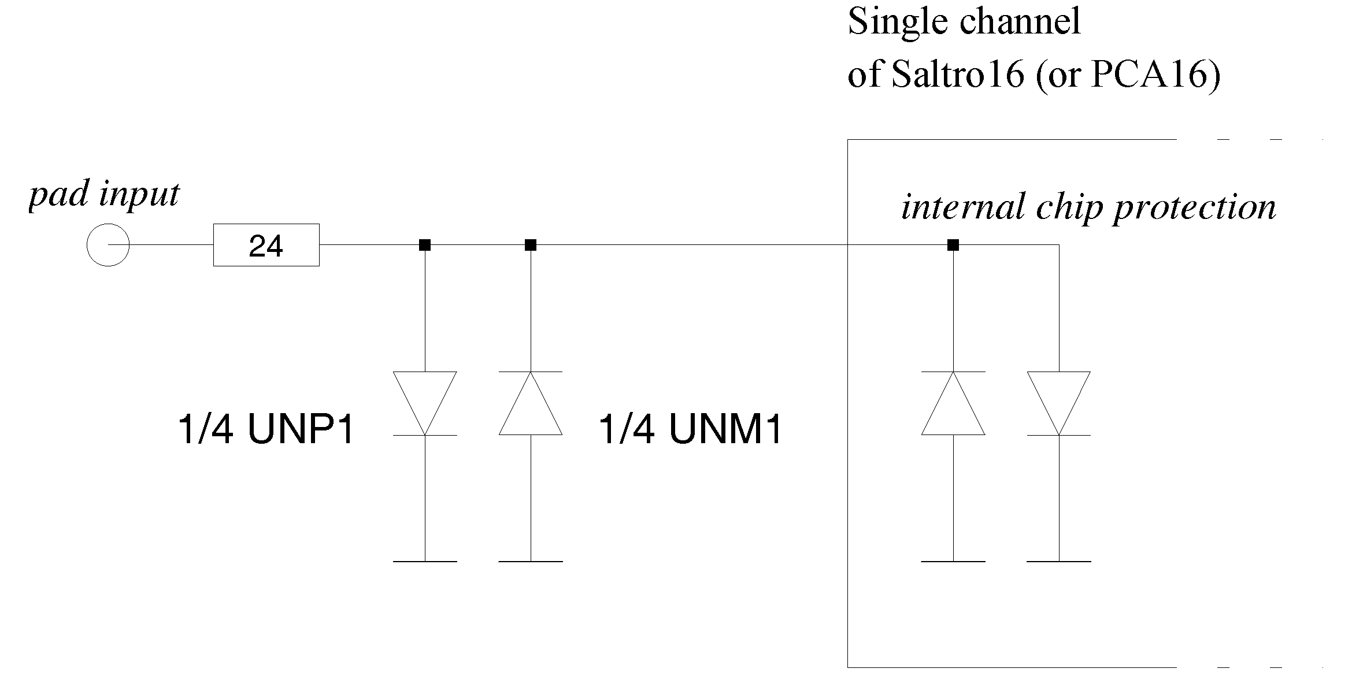
Figure 3. Chip input protection schematic

Some destructive tests were made in Lund on chips with already broken channels and it was found that a discharge energy of ~1mJ (47nF@20V) directly into the input of a PCA16 was enough to destroy the protection diodes and therefore discharges the energy into the rest of the channel amplifier thus deteriorating or destroying it as well.
A similar problem was encountered when Lund designed the front-end electronics for the ATLAS-TRT detector and a solution was to add an external protection network consisting of a dissipation resistor and larger external protection diodes.
This was sufficient to protect the inputs for discharges from 20mJ (10nF@2kV) without adding too much noise.
The same protection scheme was tested in front of a PCA16 input and subsequential tests showed that it withstood continuous discharges of 20mJ (10uF@60V).
A scheme for testing this on a full PCA16 FEC is underway and will show whether or not it introduces noise into the inputs.

If such a protection is necessary for the Saltro16 readout as well, it is preferential if these components can be inserted between the pad and the connector to the Saltro16 and should therefore preferably be placed on the backside of the padplane.
If this isn't possible, another intermediate protection card must be used as will be shown later in this document.

Modularization

In order to further increase pad-density and simplify mounting as well as system service, a modularization of the read-out system is necessary.
In such case the pad plane only needs connectors and possibly mechanical support and an input protection network since all other passive and active electronics will be placed on the plug-in card.
Such a plug-in MCM card can either be a horizontal module (parallel to the pad plane) or a vertical module (perpendicular) that can contain any practical number of Saltro16 chips.
One great advantage of a plug-in card is that Saltro16 chips can be mounted on both sides of the board thereby effectively halving the required pad-pitch vs. channel dependency.
In our case with a design goal of 1x6mm² pads, it's essential to use component mounting on both sides of the boards.

Horizontal module

A horizontally mounted plug-in card is parallel to the pad plane meaning that the total system will be more compact in depth (z) than any system incorporating vertical plug-in cards as long as the rest of the system is built in a similar manner.

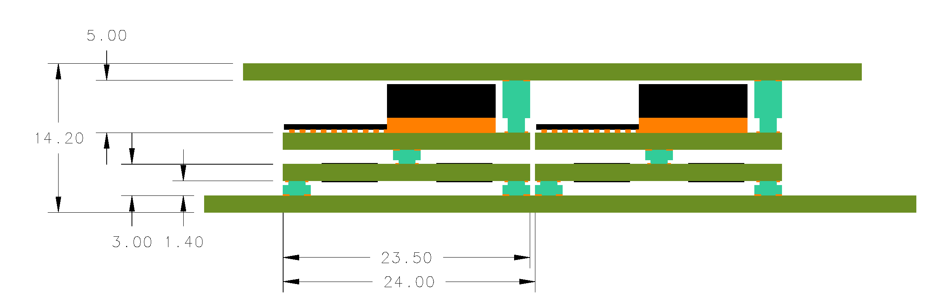
Z
Z
z
Voltage regulators
Saltro16
Figure 4. Example of horizontally mounted stack-up

Any type of plug-in module needs a connector and connectors for parallel board-to-board mounting are the most common type; it's possible to find high-density connectors down to 0.4mm pitch in x and fully mated they only occupy 1.4mm in z.
In order to keep the density as high as possible the read-out should be divided into a sandwich structure where only the Saltro16 and support components are mounted on the lowest level board.
In the case where protection components are needed and are not fitted of the padplane, it's necessary to insert another board between the horizontal Saltro16 module and the padplane.
This board should be a kind of an adapter board with the same footprint as the horizontal module but female connectors on one side and male connectors on the other so that it will just add space in z.
Such a solution would add around 3-5 mm extra space in z of which 1-2mm is a PCB.

Voltage regulators and board-controller should be mounted on one or two sandwich boards on top of the Saltro16 board.
As can be seen from figure 4, it's a compact construction and cooling will have to be carefully designed to allow transport of the heat away from the voltage regulators.

In such a system the optimum number of chips would as in the current FEC be 8 chips per board since this can use octal function support chips (e.g. 8 buffers in a package) which are common.

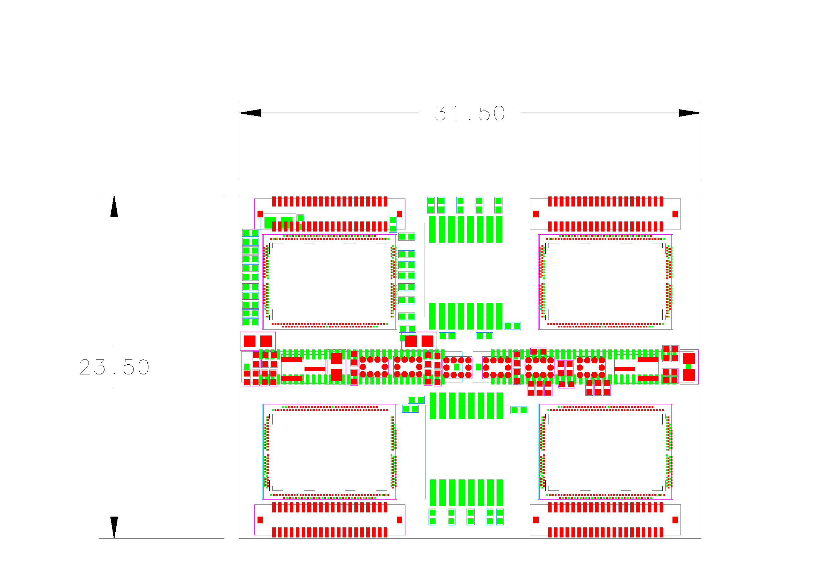
Figure 5. 8 chip horizontal FEC-MCM

This would give a pad-pitch of 5.78mm² which is ~70% of the density of chips mounted directly on the back of a pad-plane and would immensely increase serviceability although it would still be necessary to replace 8 chips at a time.

For utilizing a pad-pitch of 1x6mm², the modules would be tightly placed with around 0.5mm between boards. This would be sufficient space from mounting and assembly perspective, but for disassembling and service there is probably needed some kind of holes or mechanical support on the module itself to simplify disassembly.

Further subdivision of a horizontal module would not make sense since the active area per pad would increase due to the need of additional buffers and connectors.
Larger modules wouldn't be beneficiary either since only the number of connectors to the board-controller would remain the same whereas placement on pad plane would be increasingly difficult (see figure 6) as well as yet again the serviceability problems would increase.

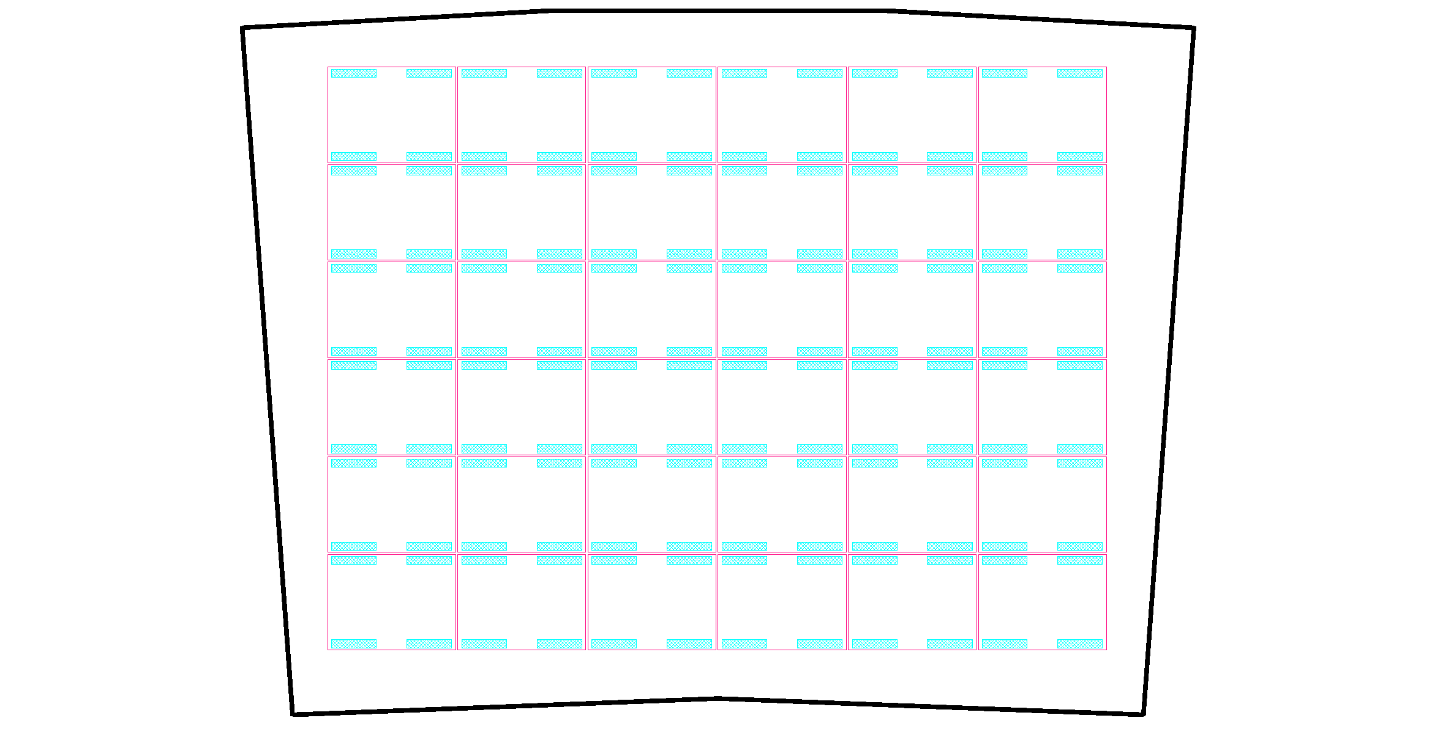
Figure 6. Above horizontal MCM superimposed on pad frame

In figure 6 a generic padplane with its connectors (blue) are shown with a suggested placement of horizontal modules on top (red) where the distance module-to-module is 0.5 mm. As can be seen, it's a fairly tight fit although not impossible depending on the mechanics surrounding the padplane.

Vertical module

In order to decrease pad-pitch another alternative is to have plug-in modules that are perpendicular to the pad plane.

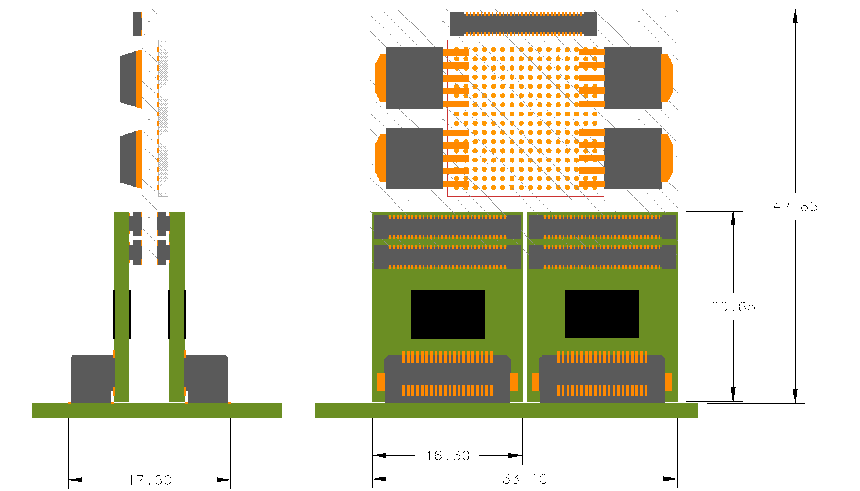
Figure 7. Vertical module with only 2 chips per MCM
It makes the system more compact in the plane of the pads but less dense in z, but at least for a prototype system this shouldn't pose a problem since it still will be quite a lot more compact than the current EUDET/LCTPC FEC system.
For cooling it will probably be better with vertical modules since there is more space for forced-air cooling or it's simpler to imagine ways to mount cooling-plates or cooling-fins.

The simplest imaginable vertical module is where only 2 Saltro16's are mounted on each MCM (figure 7).
It has the disadvantage that it still needs 2 connectors between the Saltro16 cards and board-controller card since only a few signals are unique per Saltro16 and most signals are bused to all the chips.
Unfortunately, board-to-board connectors for mounting one board perpendicular to another are far more uncommon that for parallel mounting so in such a case we will have to keep the larger 0.5mm pitch JAE connectors we currently use.
Since the occupied area of this type of arrangement depends much less on how the components are placed on the MCM and much more on card arrangement and connector size, we can calculate the pad-pitch for this module to be 4.55mm² per channel.

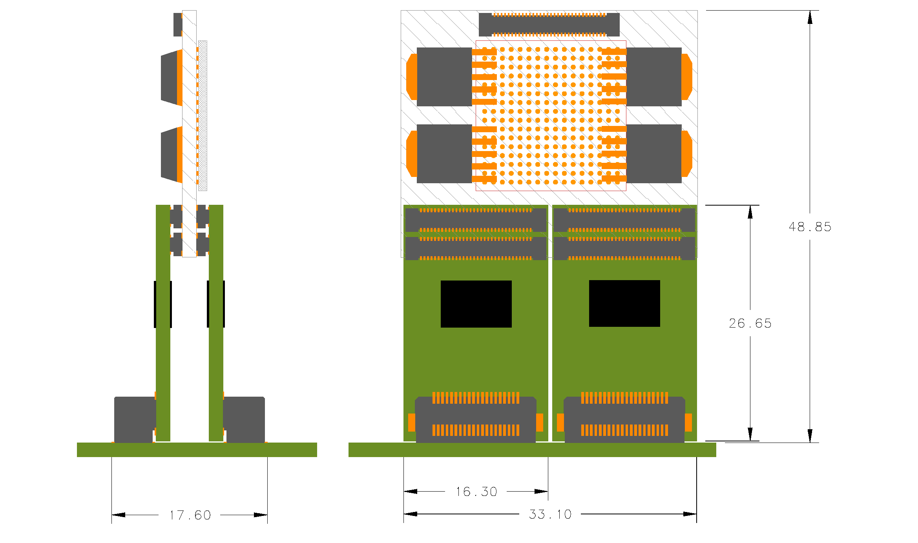
Figure 8. As in fig7 with longer 2-chip MCM to accommodate protection components

In figure 8 an alternative version is shown.
In case the protection network for the inputs is needed and not fitted on the padplane, the vertical module has to be longer (in z) to accommodate the additional components.
Unfortunately, such an approach makes it essential to determine the necessity of the protection network at the start of the design since the boards have to be designed with protection.
As is shown later in figure 10, there is also the possibility to add these components on a separate board but the additional complexity of the system and number of connectors makes it unsuitable.

The advantage of this approach is that since only 2 Saltro16 chips are mounted on each MCM, so if a chip is broken only 2 chips are replaced at a time compared to 8 for the horizontal module.
This also allows using untested chips during manufacturing, i.e. electrically not short-circuited but with untested functionality since the yield dependency will only for 2 chips per MCM.

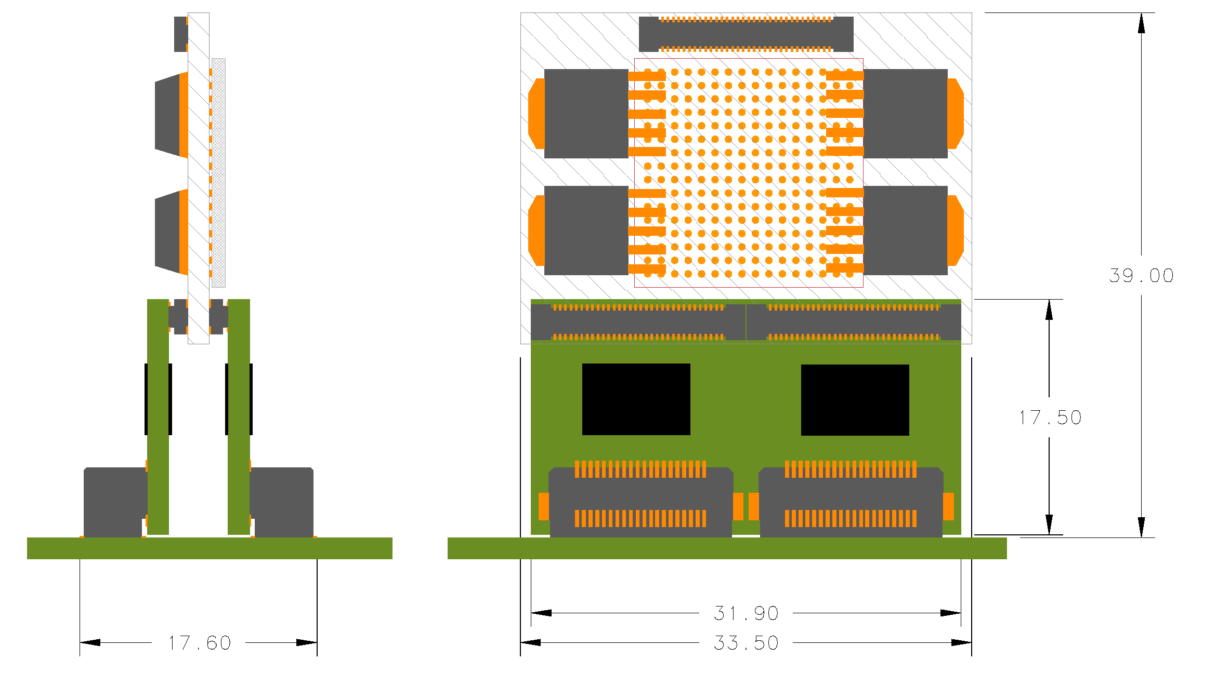
Figure 9. 4-chip vertical MCM x2 with shaded board-controller/voltage regulators

Figure 9 shows yet another approach for drafting a vertical module which is to 'fold' the horizontal MCM in the middle and instead make it into two separate vertical MCMs with 4 Saltro16 chips each.
As can be seen from figure 9 the occupied area of such a module is 31.9x17.6mm² or 4.38mm² per channel.

Figure 10 shows the same setup as figure 9 but with an additional board inserted for the protection resistor-diode network. This module arrangement is more difficult to assemble and mount because of the larger number of boards involved. Additionally the connector choice is critical here since the placement of the connectors on the padplane depends on the stacking height of the connectors (which becomes stacking width here since the boards are vertical).
This setup also adds additional space in z although there is a slight decrease in the footprint width. Figure 10 shows the minimum width allowable because of components mounted on the boards, but the actual number is dependent on the connectors.
The connector footprint on the MCM itself could be such that it's possible to mount either of the 90° connector for the padplane or the straight board-to-board connector, but not both simultaneously, although this would have to be decided on during manufacturing.
The shown footprint gives the minimum pad-pitch to be 3.99mm² but this is a more uncertain value.

Compared to the 2-chip vertical MCM, this 4-chip arrangement is slightly denser both in height and length and also uses fewer internal connectors.
Unfortunately, more chips per MCM also mean throwing away more good chips when replacing bad ones.

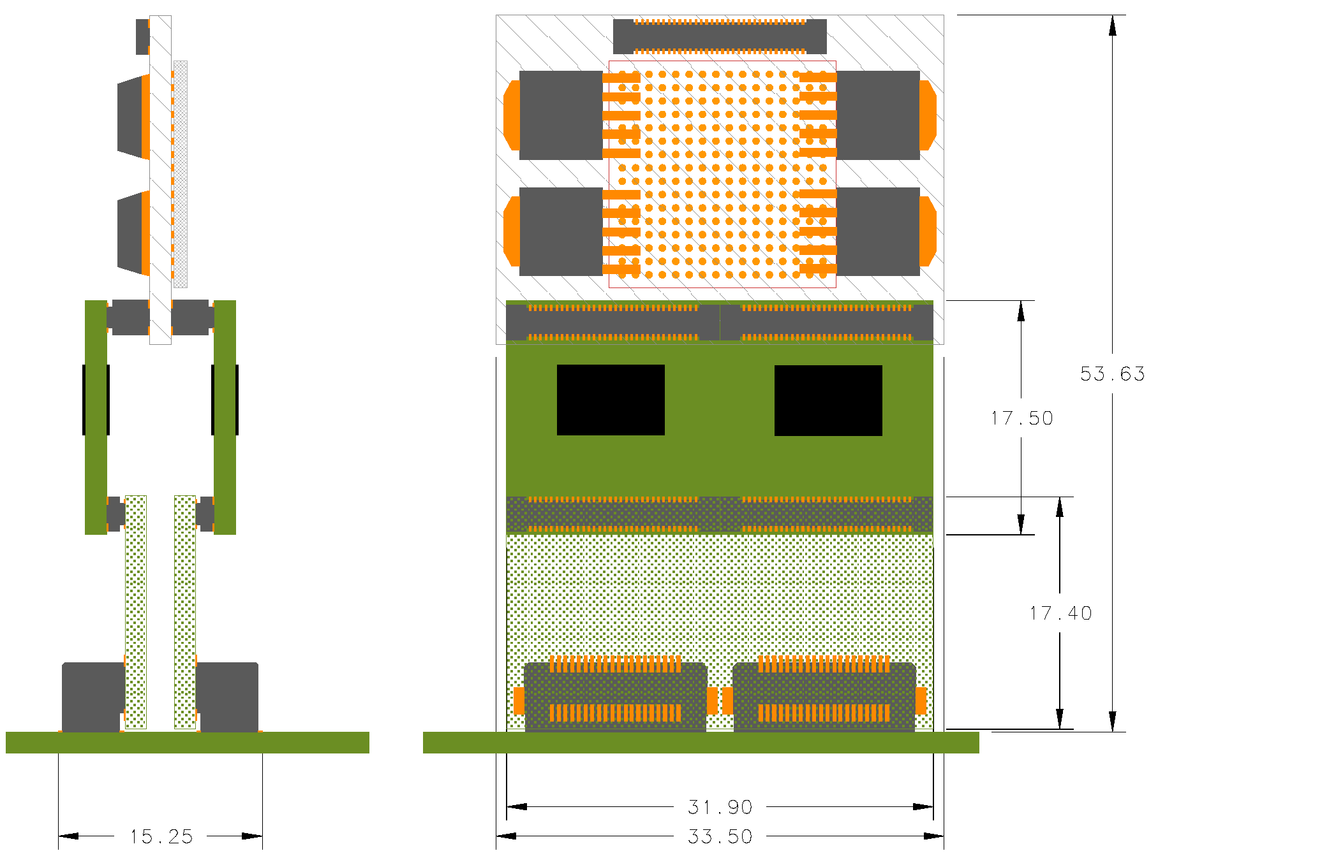
Figure 10. Vertical 4-chip module with additional protection board

The highest density of all different configurations is achieved if we instead place all 8 Saltro16 on one and the same vertical MCM. It also benefits the most from the fact that most signals on the Saltro16 bus are common and utilizes octal channel support chips, just as the horizontal module.
Although the MCM is double the length of the 2- or 4-chip vertical approach the overall density is still increased by the fact that it takes only a third of the width and as can be seen in figure 9, the area occupied by the 8chip/128 channel version vertical module is 62.7x6.6mm² or only 3.23mm² per channel!
Another advantage with this approach is that since the MCM length is doubled, the length of the board-controller module can also be doubled, giving a less dense design end also makes room for larger 'backplane' connectors as well as bus drivers (not sketched before).

Unfortunately this increase in density and simplicity is gained at the cost of the most expensive chip replacement – a module of 8 chips has to be replaced when one chips breaks and only fully tested chips can be used during manufacturing (as is the case for the horizontal module).
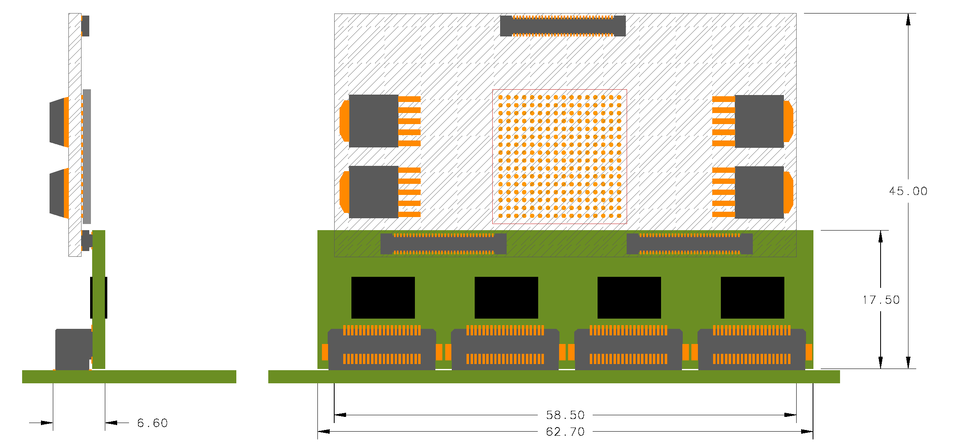
Figure 11. 8-chip version of vertical MCM

The 8-chip vertical module also suffer from the fact that it's the widest module so it might be difficult to fit it on a pad plane as can be seen from figure 12.
The orange boxes correspond to the 40-pin JAE connector and the thick black line is the 1.6mm thick 8-chip vertical MCM seen from above.

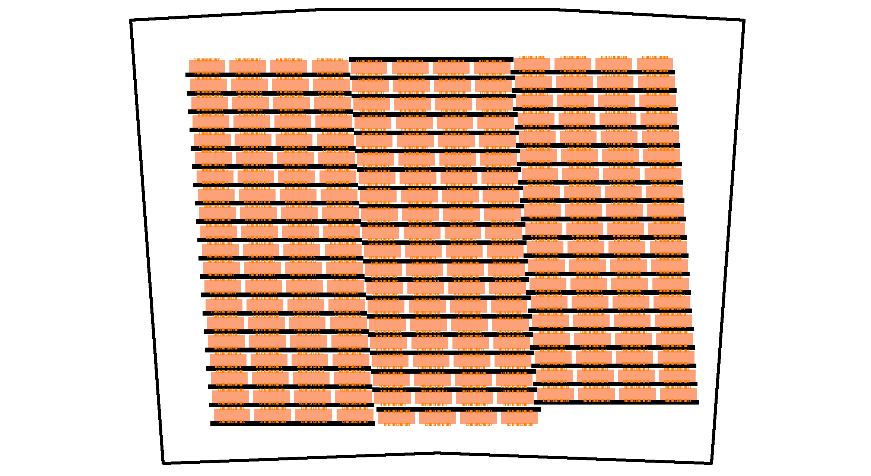
Figure 12. 8-chip vertical MCM on pad frame

Backplane & RCU

The backplane for the current EUDET/LCTPC is a rather simple and straightforward adaptation of the ALICE backplane. This backplane supports 16 FECs and 2 backplanes are connected to an RCU giving a total of 32 cards supported by an RCU.
In the cases we have studied so far, the backplane would most likely have to be a roof board scenario, i.e. a larger backplane board of irregular shape(s) placed on top of a larger number of MCMs and connecting to these.

Since the placement of a MCM FEC on the padplane is very depending on the MCM type and connector placement and is most likely irregular, a single type of roof board will have the disadvantage that only a limited number of MCMs can be accessed at a time as well as imposing limitations on where MCMs can be placed.

A Saltro16 MCM version of the FEC allows 36 cards plugged into a padplanes in the case of a horizontal module as shown in figure 6.
Unfortunately the modularity of the RCU readout is 2x16 FECs meaning that only 32 of these can be read out. It would be difficult, although not impossible, to read out the remaining 4 MCMs since there would have to be devised a solution where these would be fed through a cable to a second RCU.

In the case of figure 12 with 59 vertical 8-chip MCMs, there would have to be 4 roof boards and 2 RCUs supplying these cards since that would mean that we could use 59 out of a total of 64 FEC slots.
It would be difficult (although maybe not impossible) to find fewer than 4 different roof board designs capable of handling such a setup and in a worst case scenario some of these boards would have to be further sub-divided because of mechanical limitations.

It is also assumed based on our current experience that a simpler yet more robust power distribution system would have to be devised at the same system level as the roof board interconnects.
This is not a simple task since the current for the FECs connected to a single RCU is in the order of 10's of amperes.

Summary

The purpose of this document is not to make any decisions but to present the different choices and approaches we can foresee.
We may however summarize the preferences based on the analyses made so far.
Some of these preferences are directly contra dictionary, but this is where we'll have to try and make the best decisions based of the available facts.

- Input pads should have external protection network before chip input until we know if we can live without it or not since chips replacement is costly and difficult
- Protection components should whenever possible be placed on padplane to reduce design and mechanical complexity of read-out card.
- Saltro16 chips should be wire-bonded directly onto a MCM-L read-out card.
- Read-out cards should be as low modularity as possible to reduce number of chips replaced unnecessarily and to reduce cost of such service and manufacturing.
- High read-out modularity is needed to reduce number of connectors and intermediate boards to decrease connection problems and simplify mechanics and cooling.
- Vertical modules are preferred if minimum footprint and simpler cooling is preferred.
For prototyping it's most likely the best solution since there are more possibilities in modifying a vertical design.
- Horizontal modules are preferred whenever a compact system and simple mechanics is preferential.
The final solution should have material as evenly distributed as possible over the TPC endplate why horisontal mount is favoured here.
- Board controller, voltage regulators and backplane bus drivers should be placed on separate mezzanine board to reduce complexity, costs and service of read-out system
- Roof boards will probably have to be specially designed depending on where it is placed (i.e. several mechanically different designs)
- Power distribution and cooling issues have to be solved before designing roof boards.
- RCU placement and connection will have to be determined at the time of designing roof boards and most likely a short cable solution to the RCUs has to be included.

