SALTRO16 Bonding Information

Chip Layout:
X: 5751.18um

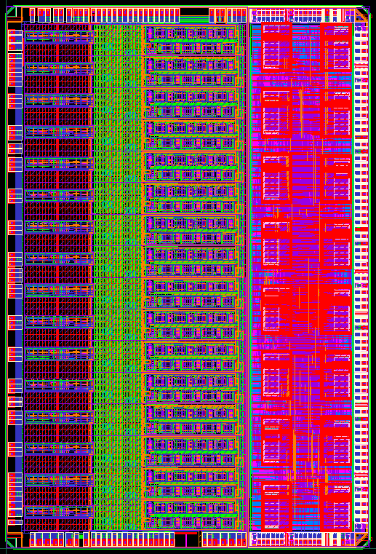
Y: 8560.00um

The center of the leftmost pad on the lower row (pad on silicon # 1)
is taken as the reference (X=0, Y=0)

The indicated sizes refer to the sizes of the CHIPEDGE layer.

The Logo positions.
The chip has two logos. Both logos are located on the left side of the chip as shown below. The upper left logo is to be located nearest pin 1 of the package.
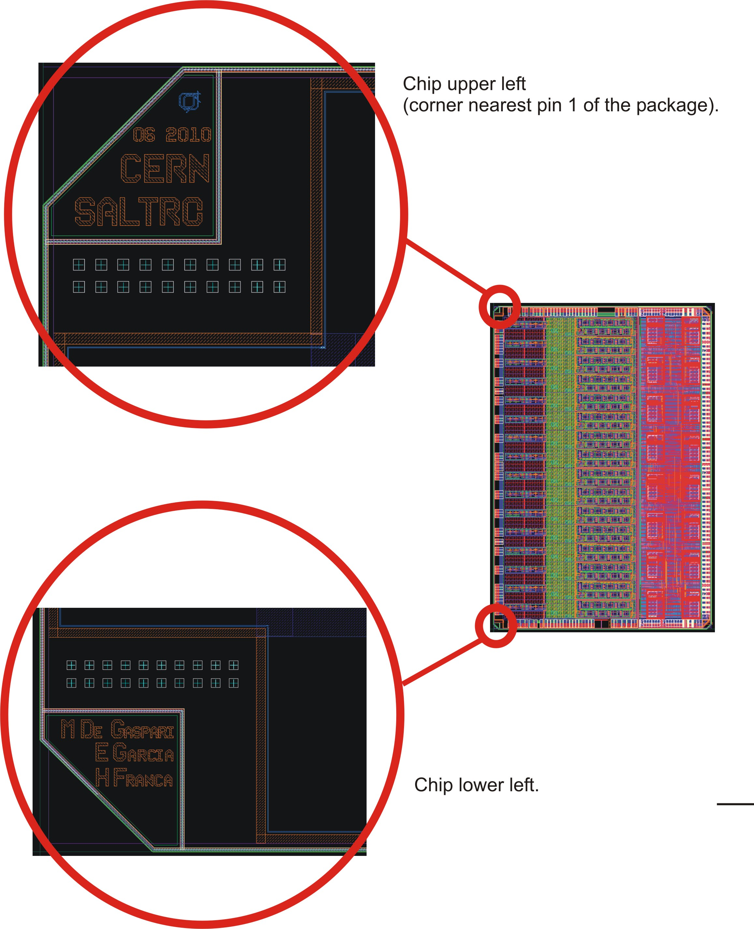

Pad names and location: Pads in brown are left unbound (NC).
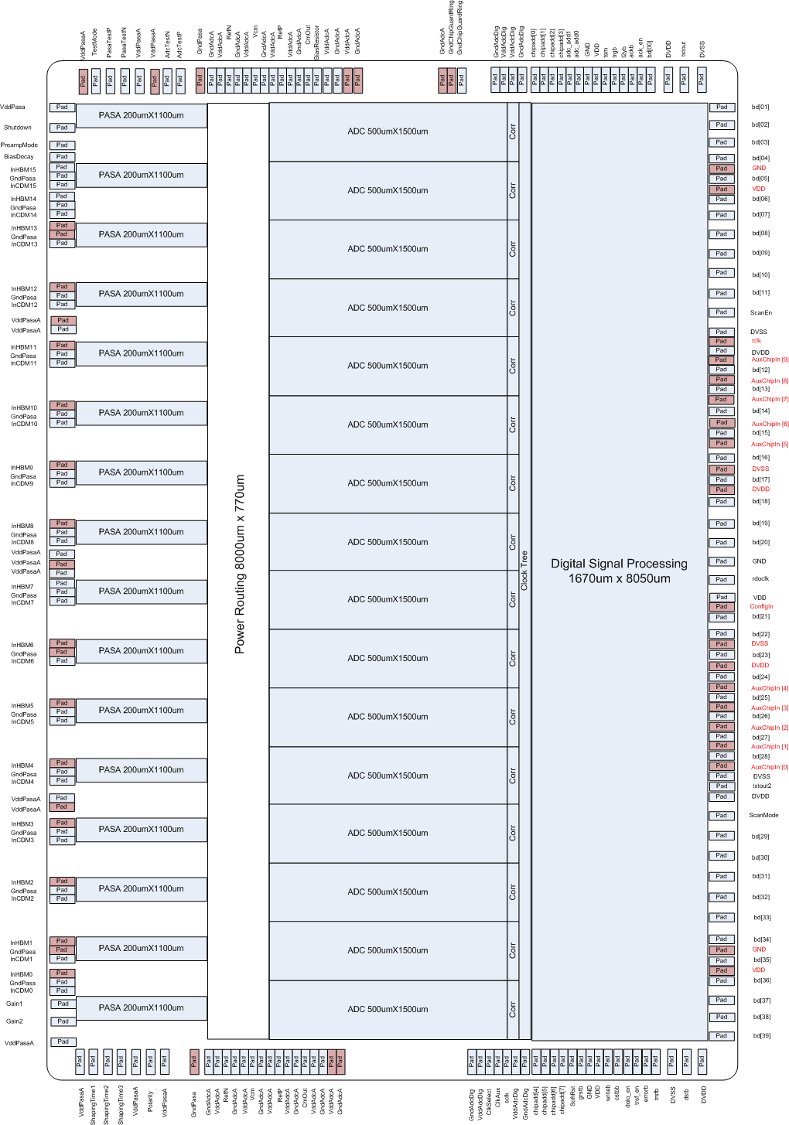
Pad on silicon #1
A total of 229 pads are located on the die; only 180 are bonded.

The table below shows the bonding connections required between the Pads on the silicon and the pins on the package. The origin for the coordinates is the center of the leftmost pad in the lower row of pads, units are um.

Pin # on Package | Pin # on Silicon | Pin Name | CenterX | CenterY
NC | 167 | VddPasaA | 0.00 | 8398.09
1 | 168 | VddPasaA | -329.55 | 8068.55
2 | 169 | Shutdown | -329.55 | 7943.55
3 | 170 | PreampMode | -329.55 | 7818.55
4 | 171 | BiasDecay | -329.55 | 7693.55
5 | 172 | InHBM15 | -329.55 | 7620.55
6 | 173 | GndPasaA | -329.55 | 7547.55
7 | 174 | InCDM15 | -329.55 | 7474.55
8 | 175 | InHBM14 | -329.55 | 7401.55
9 | 176 | GndPasaA | -329.55 | 7328.55
10 | 177 | InCDM14 | -329.55 | 7255.55
NC | 178 | InHBM13 | -329.55 | 7055.10
NC | 179 | GndPasaA | -329.55 | 6982.10
11 | 180 | InCDM13 | -329.55 | 6909.10
NC | 181 | InHBM12 | -329.55 | 6555.10
12 | 182 | GndPasaA | -329.55 | 6482.10
13 | 183 | InCDM12 | -329.55 | 6409.10
NC | 184 | VddPasaA | -329.55 | 6271.60
14 | 185 | VddPasaA | -329.55 | 6192.60
NC | 186 | InHBM11 | -329.55 | 6055.10
15 | 187 | GndPasaA | -329.55 | 5982.10
16 | 188 | InCDM11 | -329.55 | 5909.10
NC | 189 | InHBM10 | -329.55 | 5555.10
17 | 190 | GndPasaA | -329.55 | 5482.10
18 | 191 | InCDM10 | -329.55 | 5409.10
NC | 192 | InHBM9 | -329.55 | 5055.10
19 | 193 | GndPasaA | -329.55 | 4982.10
20 | 194 | InCDM9 | -329.55 | 4909.10
NC | 195 | InHBM8 | -329.55 | 4555.10
21 | 196 | GndPasaA | -329.55 | 4482.10
22 | 197 | InCDM8 | -329.55 | 4409.10
23 | 198 | VddPasaA | -329.55 | 4308.10
NC | 199 | VddPasaA | -329.55 | 4232.10
24 | 200 | VddPasaA | -329.55 | 4156.10
25 | 201 | InHBM7 | -329.55 | 4055.10
26 | 202 | GndPasaA | -329.55 | 3982.10
27 | 203 | InCDM7 | -329.55 | 3909.10
NC | 204 | InHBM6 | -329.55 | 3555.10
NC | 205 | GndPasaA | -329.55 | 3482.10
28 | 206 | InCDM6 | -329.55 | 3409.10
NC | 207 | InHBM5 | -329.55 | 3055.10
29 | 208 | GndPasaA | -329.55 | 2982.10
30 | 209 | InCDM5 | -329.55 | 2909.10
NC | 210 | InHBM4 | -329.55 | 2555.10
31 | 211 | GndPasaA | -329.55 | 2482.10
32 | 212 | InCDM4 | -329.55 | 2409.10
33 | 213 | VddPasaA | -329.55 | 2271.60
NC | 214 | VddPasaA | -329.55 | 2192.60
NC | 215 | InHBM3 | -329.55 | 2055.10
34 | 216 | GndPasaA | -329.55 | 1982.10
35 | 217 | InCDM3 | -329.55 | 1909.10
NC | 218 | InHBM2 | -329.55 | 1555.10
36 | 219 | GndPasaA | -329.55 | 1482.10
37 | 220 | InCDM2 | -329.55 | 1409.10
NC | 221 | InHBM1 | -329.55 | 1069.55
NC | 222 | GndPasaA | -329.55 | 996.55
38 | 223 | InCDM1 | -329.55 | 923.55
NC | 224 | InHBM0 | -329.55 | 850.55
39 | 225 | GndPasaA | -329.55 | 777.55
40 | 226 | InCDM0 | -329.55 | 704.55
41 | 227 | Gain1 | -329.55 | 579.55
42 | 228 | Gain2 | -329.55 | 454.55
43 | 229 | VddPasaA | -329.55 | 329.55
44 | 1 | VddPasaA | 0.00 | 0.00
45 | 2 | ShapingTime1 | 125.00 | 0.00
46 | 3 | ShapingTime2 | 250.00 | 0.00
47 | 4 | ShapingTime3 | 375.00 | 0.00
48 | 5 | VddPasaA | 453.90 | 0.00
49 | 6 | Polarity | 607.97 | 0.00
50 | 7 | VddPasaA | 699.34 | 0.00
NC | 8 | GndPasaA | 846.36 | 0.00
51 | 9 | GndAdcA | 968.89 | 0.00
52 | 10 | VddAdcA | 1049.26 | 0.00
53 | 11 | RefN | 1133.57 | 0.00
54 | 12 | GndAdcA | 1217.89 | 0.00
55 | 13 | VddAdcA | 1298.26 | 0.00
56 | 14 | Vcm | 1382.57 | 0.00
57 | 15 | GndAdcA | 1466.89 | 0.00
58 | 16 | VddAdcA | 1547.26 | 0.00
59 | 17 | RefP | 1631.57 | 0.00
60 | 18 | VddAdcA | 1713.26 | 0.00
61 | 19 | GndAdcA | 1798.89 | 0.00
62 | 20 | CmOut | 1880.57 | 0.00
63 | 21 | VddAdcA | 1962.25 | 0.00
64 | 22 | GndAdcA | 2043.93 | 0.00
NC | 23 | VddAdcA | 2125.61 | 0.00
NC | 24 | GndAdcA | 2207.29 | 0.00
65 | 25 | GndAdcDig | 2728.90 | 0.00
66 | 26 | VddAdcDig | 2806.10 | 0.00
67 | 27 | ClkSelect | 2883.30 | 0.00
68 | 28 | ClkAux | 3013.30 | 0.00
69 | 29 | sclk | 3143.30 | 0.00
70 | 30 | VddAdcDig | 3273.30 | 0.00
71 | 31 | GndAdcDig | 3350.73 | 0.00
72 | 32 | chipadd [4] | 3585.32 | 0.00
73 | 33 | chipadd [5] | 3658.32 | 0.00
74 | 34 | chipadd [6] | 3731.32 | 0.00
75 | 35 | chipadd [7] | 3804.32 | 0.00
76 | 36 | SoftRst | 3877.32 | 0.00
77 | 37 | grstb | 3950.32 | 0.00
78 | 38 | GND | 4023.32 | 0.00
79 | 39 | VDD | 4100.32 | 0.00
80 | 40 | writeb | 4173.32 | 0.00
81 | 41 | cstbb | 4246.32 | 0.00
82 | 42 | dolo_en | 4319.32 | 0.00
83 | 43 | trsf_en | 4392.32 | 0.00
84 | 44 | errorb | 4465.32 | 0.00
85 | 45 | trsfb | 4538.32 | 0.00
86 | 46 | DVSS | 4663.32 | 0.00
87 | 47 | dstb | 4788.32 | 0.00
88 | 48 | DVDD | 4913.32 | 0.00
89 | 49 | bd[39] | 5259.72 | 365.50
90 | 50 | bd[38] | 5259.72 | 490.50
91 | 51 | bd[37] | 5259.72 | 615.50
92 | 52 | bd[36] | 5259.72 | 740.50
NC | 53 | VDD | 5259.72 | 852.60
93 | 54 | bd[35] | 5259.72 | 963.60
NC | 55 | GND | 5259.72 | 1074.60
94 | 56 | bd[34] | 5259.72 | 1185.60
95 | 57 | bd[33] | 5259.72 | 1296.60
96 | 58 | bd[32] | 5259.72 | 1407.60
97 | 59 | bd[31] | 5259.72 | 1518.60
98 | 60 | bd[30] | 5259.72 | 1629.60
99 | 61 | bd[29] | 5259.72 | 1740.60
100 | 62 | ScanMode | 5259.72 | 1851.60
101 | 63 | DVDD | 5259.72 | 1962.60
102 | 64 | tstout2 | 5259.72 | 2073.60
103 | 65 | DVSS | 5259.72 | 2184.60
NC | 66 | AuxChipIn[0] | 5259.72 | 2295.60
104 | 67 | bd[28] | 5259.72 | 2406.60
NC | 68 | AuxChipIn[1] | 5259.72 | 2517.60
105 | 69 | bd[27] | 5259.72 | 2628.60
NC | 70 | AuxChipIn[2] | 5259.72 | 2739.60
106 | 71 | bd[26] | 5259.72 | 2850.60
NC | 72 | AuxChipIn[3] | 5259.72 | 2961.60
107 | 73 | bd[25] | 5259.72 | 3072.60
NC | 74 | AuxChipIn[4] | 5259.72 | 3183.60
108 | 75 | bd[24] | 5259.72 | 3294.60
NC | 76 | DVDD | 5259.72 | 3405.60
109 | 77 | bd[23] | 5259.72 | 3516.60
NC | 78 | DVSS | 5259.72 | 3627.60
110 | 79 | bd[22] | 5259.72 | 3738.60
111 | 80 | bd[21] | 5259.72 | 3849.60
NC | 81 | ConfigIn | 5259.72 | 3960.60
112 | 82 | VDD | 5259.72 | 4071.60
113 | 83 | rdoclk | 5259.72 | 4182.60
114 | 84 | GND | 5259.72 | 4293.60
115 | 85 | bd[20] | 5259.72 | 4404.60
116 | 86 | bd[19] | 5259.72 | 4515.60
117 | 87 | bd[18] | 5259.72 | 4626.60
NC | 88 | DVDD | 5259.72 | 4737.60
118 | 89 | bd[17] | 5259.72 | 4848.60
NC | 90 | DVSS | 5259.72 | 4959.60
119 | 91 | bd[16] | 5259.72 | 5070.60
NC | 92 | AuxChipIn[5] | 5259.72 | 5181.60
120 | 93 | bd[15] | 5259.72 | 5292.60
NC | 94 | AuxChipIn[6] | 5259.72 | 5403.60
121 | 95 | bd[14] | 5259.72 | 5514.60
NC | 96 | AuxChipIn[7] | 5259.72 | 5625.60
122 | 97 | bd[13] | 5259.72 | 5736.60
NC | 98 | AuxChipIn[8] | 5259.72 | 5849.60
123 | 99 | bd[12] | 5259.72 | 5962.60
NC | 100 | AuxChipIn[9] | 5259.72 | 6075.60
124 | 101 | DVDD | 5259.72 | 6188.60
NC | 102 | tclk | 5259.72 | 6301.60
125 | 103 | DVSS | 5259.72 | 6414.60
126 | 104 | ScanEn | 5259.72 | 6527.60
127 | 105 | bd[11] | 5259.72 | 6640.60
128 | 106 | bd[10] | 5259.72 | 6753.60
129 | 107 | bd[09] | 5259.72 | 6866.60
130 | 108 | bd[08] | 5259.72 | 6979.60
131 | 109 | bd[07] | 5259.72 | 7092.60
132 | 110 | bd[06] | 5259.72 | 7203.90
NC | 111 | VDD | 5259.72 | 7315.20
133 | 112 | bd[05] | 5259.72 | 7426.50
NC | 113 | GND | 5259.72 | 7537.70
134 | 114 | bd[04] | 5259.72 | 7650.70
135 | 115 | bd[03] | 5259.72 | 7775.70
136 | 116 | bd[02] | 5259.72 | 7900.70
137 | 117 | bd[01] | 5259.72 | 8025.70
138 | 118 | DVSS | 4913.32 | 8398.09
139 | 119 | tstout | 4788.32 | 8398.09
140 | 120 | DVDD | 4663.32 | 8398.09
141 | 121 | bd[00] | 4538.32 | 8398.09
142 | 122 | ack_en | 4465.32 | 8398.09
143 | 123 | ackb | 4392.32 | 8398.09
144 | 124 | l2yb | 4319.32 | 8398.09
145 | 125 | trgb | 4246.32 | 8398.09
146 | 126 | tsm | 4173.32 | 8398.09
147 | 127 | VDD | 4096.32 | 8398.09
148 | 128 | GND | 4023.32 | 8398.09
149 | 129 | adc_add0 | 3950.32 | 8398.09
150 | 130 | adc_add1 | 3877.32 | 8398.09
151 | 131 | chipadd [3] | 3804.32 | 8398.09
152 | 132 | chipadd [2] | 3731.32 | 8398.09
153 | 133 | chipadd [1] | 3658.32 | 8398.09
154 | 134 | chipadd [0] | 3585.32 | 8398.09
155 | 135 | GndAdcDig | 3350.38 | 8398.09
156 | 136 | VddAdcDig | 3273.30 | 8398.09
157 | 137 | VddAdcDig | 3196.22 | 8398.09
158 | 138 | GndAdcDig | 3119.14 | 8398.09
159 | 139 | GndChipGuardRing | 3010.58 | 8398.09
NC | 140 | GndChipGuardRing | 2937.58 | 8398.09
NC | 141 | GndAdcA | 2837.41 | 8398.09
NC | 142 | GndAdcA | 2292.92 | 8398.09
NC | 143 | VddAdcA | 2211.24 | 8398.09
160 | 144 | GndAdcA | 2129.56 | 8398.09
161 | 145 | VddAdcA | 2047.88 | 8398.09
162 | 146 | BiasGate | 1966.20 | 8398.09
163 | 147 | CmOut | 1883.20 | 8398.09
164 | 148 | GndAdcA | 1798.89 | 8398.09
165 | 149 | VddAdcA | 1718.52 | 8398.09
166 | 150 | RefP | 1634.20 | 8398.09
167 | 151 | VddAdcA | 1552.52 | 8398.09
168 | 152 | GndAdcA | 1466.89 | 8398.09
169 | 153 | Vcm | 1385.20 | 8398.09
170 | 154 | VddAdcA | 1303.52 | 8398.09
171 | 155 | GndAdcA | 1217.89 | 8398.09
172 | 156 | RefN | 1136.20 | 8398.09
173 | 157 | VddAdcA | 1054.52 | 8398.09
174 | 158 | GndAdcA | 968.89 | 8398.09
NC | 159 | GndPasaA | 852.30 | 8398.09
175 | 160 | AdcTestP | 766.67 | 8398.09
176 | 161 | AdcTestN | 683.67 | 8398.09
NC | 162 | VddPasaA | 582.66 | 8398.09
177 | 163 | VddPasaA | 453.90 | 8398.09
178 | 164 | PasaTestN | 375.00 | 8398.09
179 | 165 | PasaTestP | 250.00 | 8398.09
180 | 166 | TestMode | 125.00 | 8398.09

The size of the opening of each pad is 95.03um x 62.00um.
The minimum pad pitch is 73um.

Total # signal IOs: 115.
Total # power pins: 65.

Bonding diagram in package PGA180:
Upper left logo
Package pin #1

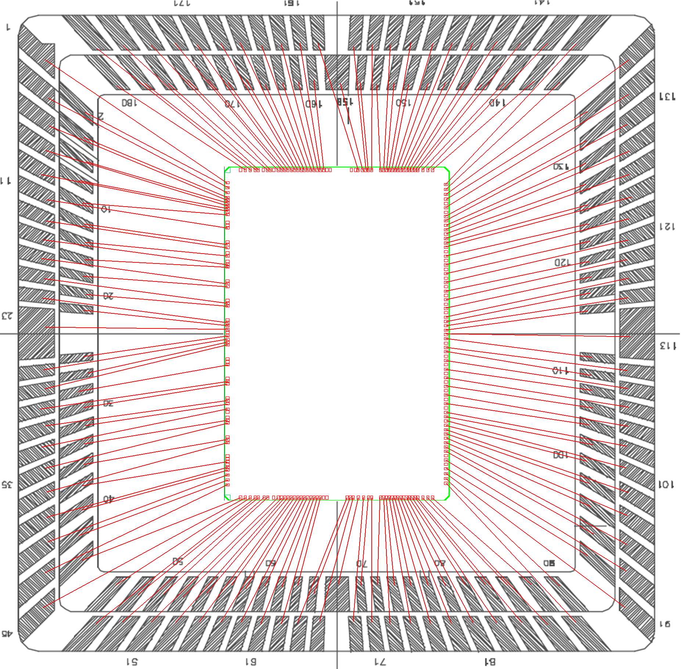
Pad on silicon #168
Lower left logo

Orientation of the silicon die: package pin #1 corresponds to pad on silicon #168.

Power domains:

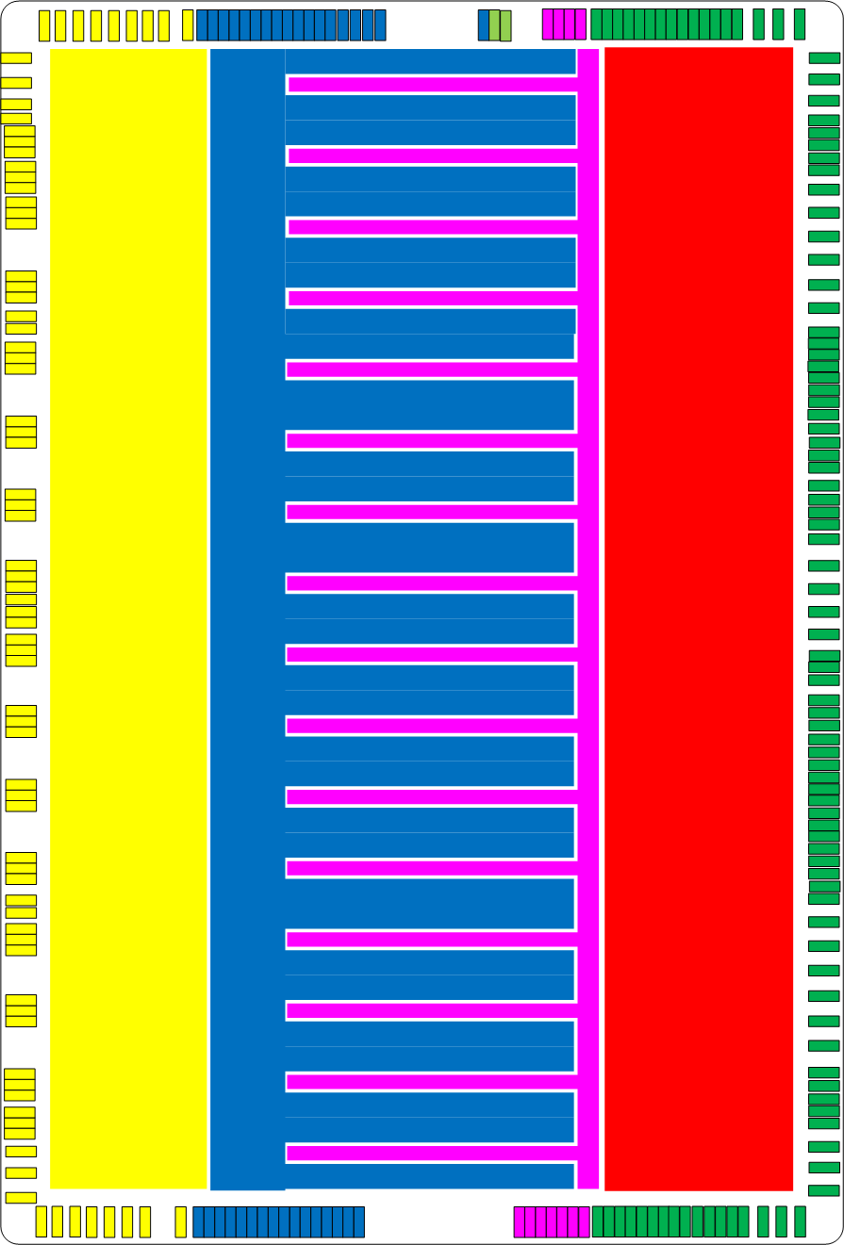

Yellow: power domain of GndPasaA / VddPasaA; 135mW @ 1.5V.
Blue: power domain of GndAdcA / VddAdcA; 600mW @ 1.5V.
Purple: power domain of GndAdcDig / VddAdcDig; 150mW @ 1.5V.
Red: power domain of GND / VDD; 150mW @1.5V.
Green: power domain of DVSS / DVDD; 150mW @ 2.5V.
Light green: connection to the chip guard ring.

Next page:
Connections of the signals on the pins of the package. The colors correspond to the power domains. The grey rectangles are meant to identify the analog inputs of each channel and the PasaTest and AdcTest IOs of the test channel.

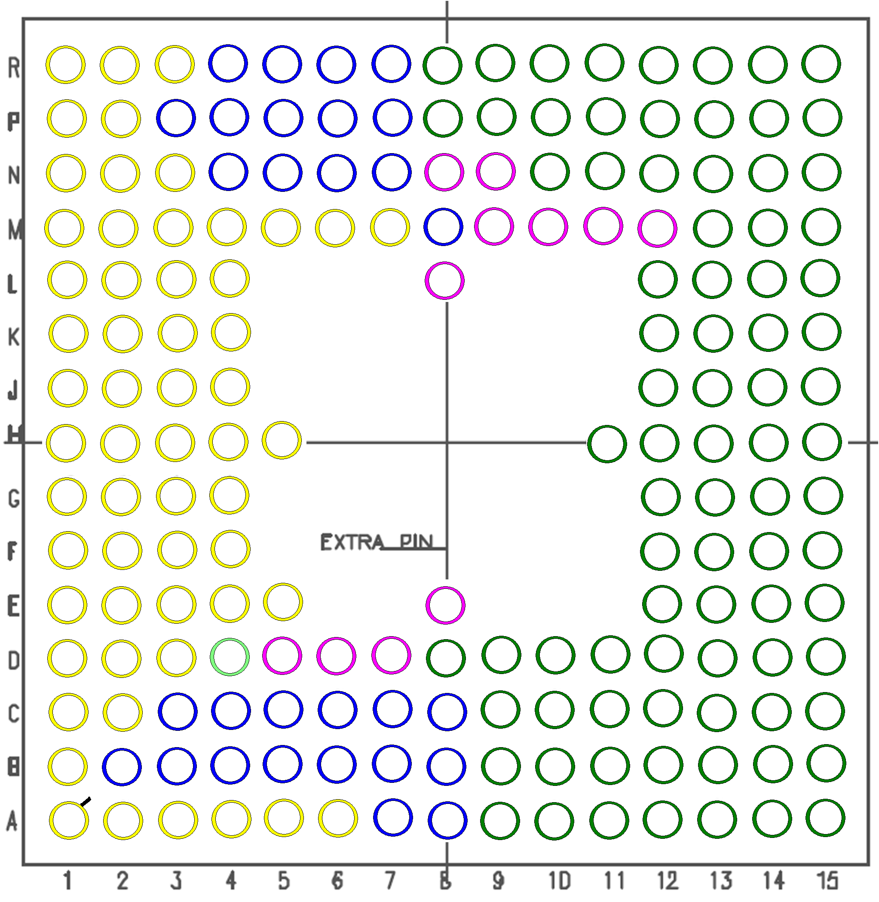
PasaTest
AdcTest
19
172
144
149
153
166
154
136
150
145
139
135
128
122
117
129
123
118
97
108
109
104
98
91
75
82
90
83
76
113 rdoclk
177 Vdd
174 Gnd
173 Vdd
171 Gnd
170 Vdd
168 Gnd
167 Vdd
165 Vdd
164 Gnd
161 Vdd
160 Gnd
159 Gnd
158 Gnd
157 Vdd
156 Vdd
155 Gnd
148 Gnd
147 Vdd
140 DVdd
138 DVss
125 DVss
124 DVdd
114 Gnd
112 Vdd
103 DVss
101 DVdd
88 DVdd
86 DVss
79 Vdd
78 Gnd
69 sclk
67 ClkSelect
68 ClkAux
71 Gnd
70 Vdd
59
66 Vdd
65 Gnd
64 Gnd
63 Vdd
61 Gnd
60 Vdd
57 Gnd
58 Vdd
55 Vdd
54 Gnd
52 Vdd
51 Gnd
48 Vdd
46
50 Vdd
49
45
38
32
27
28
22
18
13
7
8
180
39 Gnd
36 Gnd
34 Gnd
31 Gnd
29 Gnd
26 Gnd
21 Gnd
19 Gnd
17 Gnd
15 Gnd
12 Gnd
9 Gnd
6 Gnd
43 Vdd
44 Vdd
33 Vdd
24 Vdd
23 Vdd
14 Vdd
1 Vdd

