FIRE PROTECTION AND ACCIDENTS
Particle Physics
20200331

Everybody is supposed to know where the fire protection equipment is and how to use it,
and to know the evacuation routes and rules.
Responsible persons (in Swedish “Brandskyddsansvariga”): David Silvermyr, Balazs Konya

This document can be found at:
http://www.hep.lu.se/safety/doc/brandskydd.pdf

Fire extinguishers
Signs informs where the fire extinguisher can be found. There are four places with fire extinguishers, three are in the corridor and one in the south staircase.

Location: north side of the corridor at room A403.
Type: Carbon dioxide (in Swedish “Kolsyra”)
Use for: liquids, plastics, electrical equipment
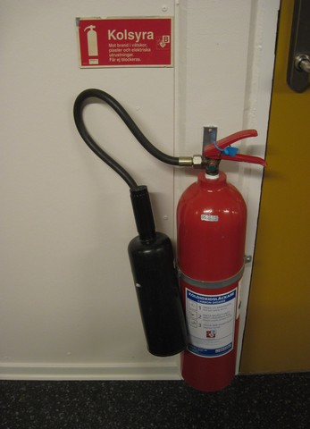
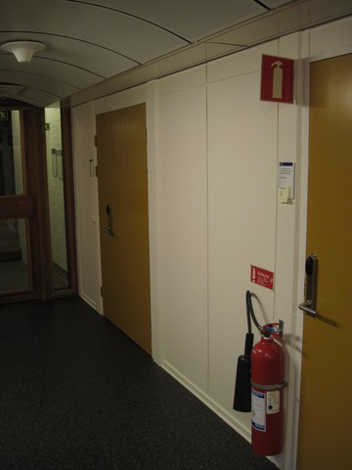

Location: middle of corridor between A405 and A406.
Type: Foam (in Swedish “Skum”)
Use for: non electrical equipment as paper, wood, etc

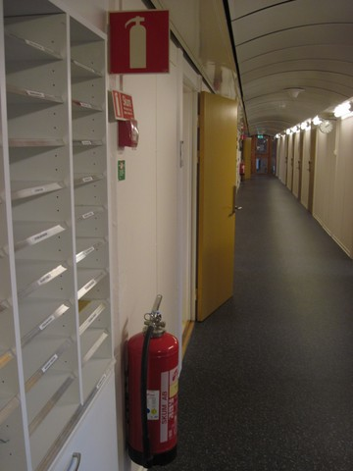
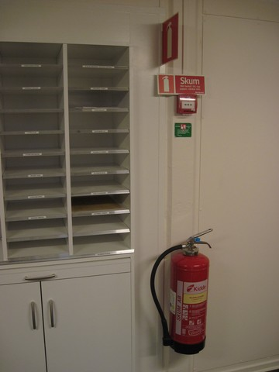

Location: south end of the corridor between A411 and A413
Type: Foam (in Swedish “Skum” )
Use for: non electrical equipment as paper, wood, etc

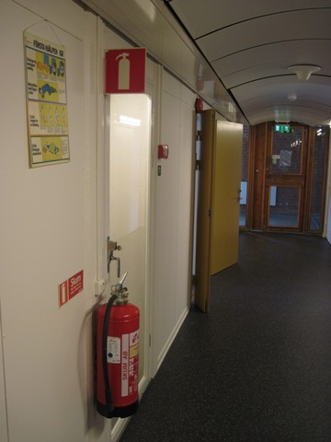
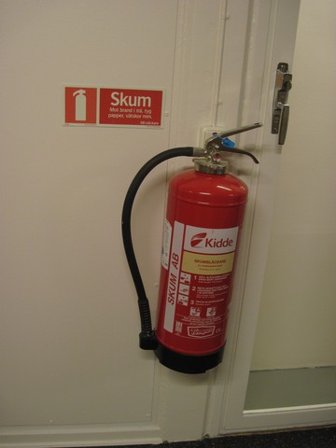

Location: south staircase
Type: Foam (in Swedish “Skum” ) and water hose (in Swedish “vattenslang”)
Use for: non electrical equipment as paper, wood, etc

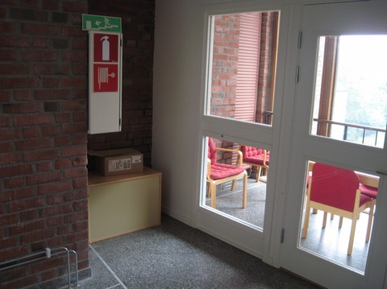

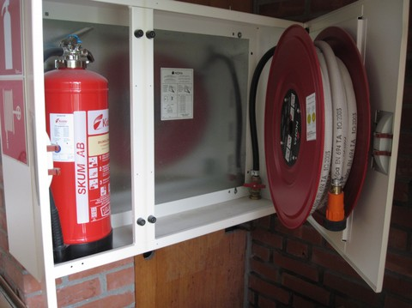

Extinguishers in the south staircase

Evacuation plan
In the case of an evacuation alarm everybody MUST evacuate. It is not allowed to stay in the house. Evacuate via the staircases at either end of the corridor, after evacuation we meet at the the assembly point “Återsamlingsplats” outside the main entrance as shown on the pictures below. Evacuation information is located at the south end of the corridor and in the north staircase.

Instruction on what to do in case you notice a fire or other danger is written on the evacuation information, here translated into english.
- Warn/Rescue those in immediate danger
- Call the fire brigade 0-112 (zero one one two)
- Warn everybody else
- Try to extinguish the fire if you consider it possible
- Evacuate according to the evacuation plan
- The elevator may not be used during evacuation
- Keep all doors closed to prevent the fire from spreading
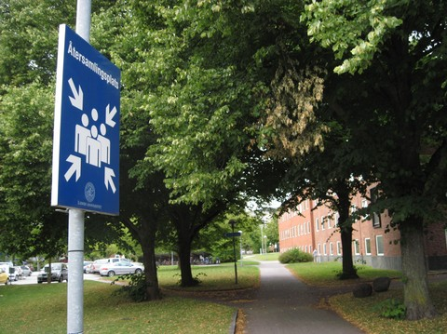

The sign : Återsamlingsplats

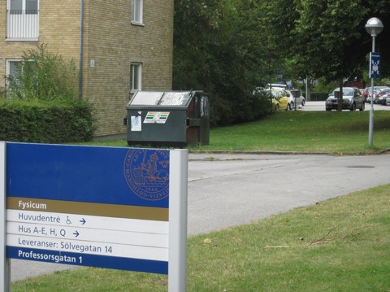

Återsamlingsplats outside main entrance

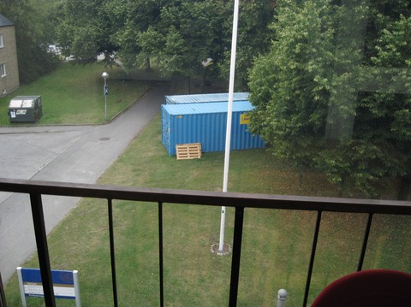

As seen from south staircase.

The arrows show the location of the “Återsamlingsplats”.

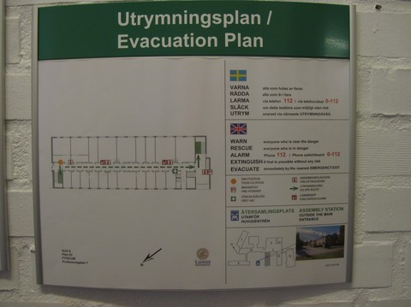

Evacuation plan
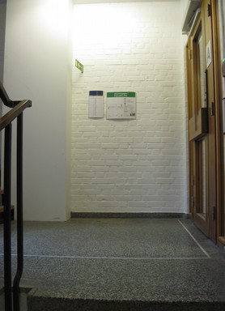

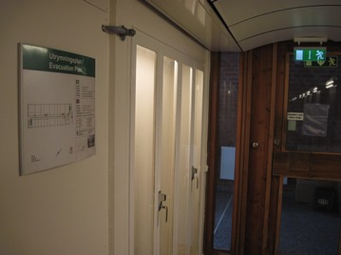

In south end of the corridor

In north staircase
Evacuation sign and Fire protections doors
Evacuation signs are location above the doors at both ends of the corridor. The doors can stand a fire for some time and are not allowed to be left open unattended for a longer time.
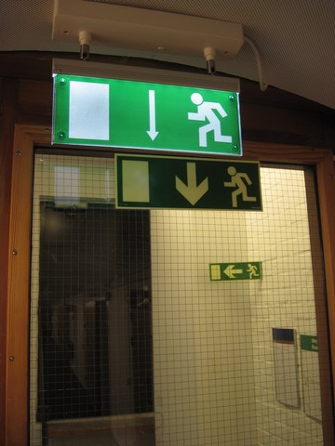
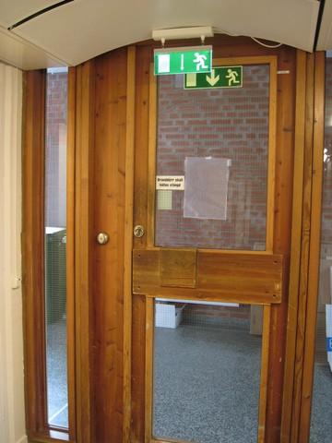

North end of corridor South end of corridor

Responsible persons (“Brandskyddsansvariga”)

Personnel with orange jacket with the text “FYSICUM, Brandskyddsansvarig” will assist during evacuation and is responsible for controlling that nobody is left in the building, if possible, and to count those who has evacuated to the assembly point.

Responsible persons (in Swedish “Brandskyddsansvariga”) at Particle Physics:
David Silvermyr (david.silvermyr@hep.lu.se)
Balazs Konya (balazs.konya@hep.lu.se) - deputy

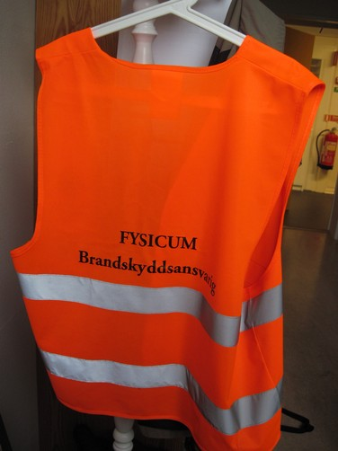
Fire alarm
Alarm buttons are located between A405 and A406 (close to the fire extinguisher) and between A411 and A413 (close to the fire extinguisher). These are directly connected to the evacuation alarm and fire brigade.
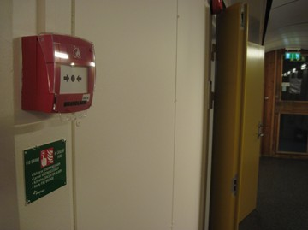
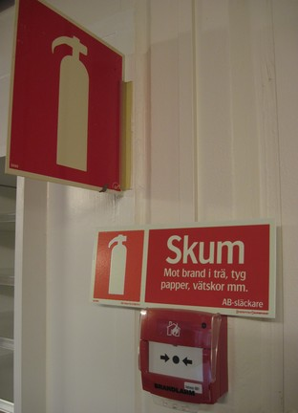

Fire alarm buttons: left - middle of corridor and right - south end of corridor
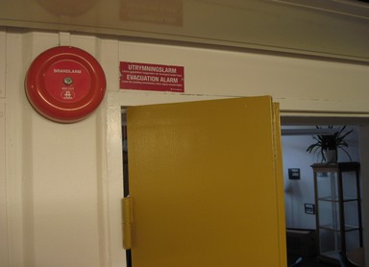

Evacuation alarm bell

First Aid Kit and Defillibrator (Hjärtstartare)
On the wall close A429, close to the south end of corridor, is a first aid kit. Try to help the sick/injured person, and if serious call 112. Several persons at the division has taken part in the first aid course:
Bozena Wlosinska (A423)
Else Lytken (A426)
Peter Christiansen(A424)
David Silvermyr (A429)

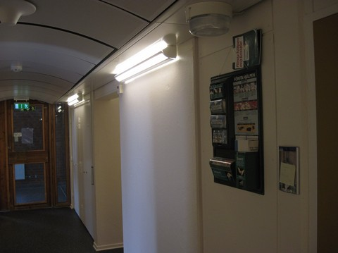

Defillibrators can be found at the reception and in the corridor A200 close to the south staircase.
NOTE: The instructions are in Swedish!

SAFETY REPRESENTATIVES (in Swedish “Skyddsombud”)
The safety representatives (in Swedish “Skyddsombud”) are:
David Silvermyr (A429) david.silvermyr@hep.lu.se
Lennart Österman (A410) lennart.osterman@hep.lu.se - deputy

